STRAIN ENERGY
Strain Energy = Stored energy due to deformation
= Work done for deformation (Within Elastic limit/Proportionality limit)
“Strain Energy is capable to doing some work”  Resilience: Strain energy stored within elastic limit.  U_{R} = [ A_{σ-ε}] * Volume  = (1/2) σ ε * V  By hook’s Law,  U_{R} = (1/2) (σ²V / E)  Proof Resilience: Maximum Strain energy stored up to elastic limit.  U_{PR} = (1/2) (σ² V / E), here σ = Stress at elastic limit  Toughness: Strain energy stored up to Fracture.  Toughness is maximum amount of shock energy absorbed before fracture.  Toughness is useful for while designing accidental over loading. | 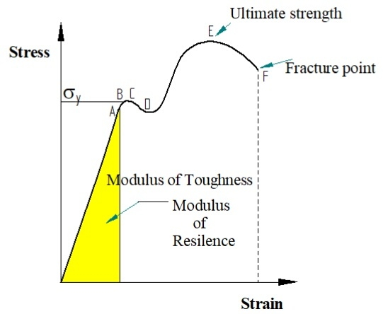

Strain Energy / Volume
Modulus of Resilience | Modulus of Toughness
(Strain Energy/Volume) up to elastic limit/ Proportionality limit | (Strain Energy/Volume) till fracture
[ A_{σ-ε}] up to Proportionality limit | [ A_{σ-ε}] till fracture

Can we change resilience and toughness? Yes, By Alloying we can change property.
Toughness depends on Strength and ductility.
Eg. Hard Steel (0.6%C), Soft Steel (0.1%C), Structure Steel (0.2%C) (Moderate Toughness)
Young’s Modulus remains constant when alloying material.

Strain Energy Stored due to following loading
Axial Loading | Bending | Torsion | Shear
Strain Energy Due to Axial Loading:
For Gradually Applied Load,
Work Done = Work Stored
(1/2) P δL = (1/2) σ ε * Volume
From Young’s Modulus,
σ = P / A
U_{G} = (1/2) (P²V / A²E)
For Suddenly Applied Load,
Work Done = Work Stored
P δL = (1/2) σ ε * Volume
From Young’s Modulus,
σ = 2P / A
U_{S} = 4 U_{G}
For Impact Load,
Work Done = Work Stored ===> P (h + δL) = (1/2) σ ε * Volume
From Young’s Modulus,
$$σ= \frac{P}{A}\left[1+ \sqrt{1+ \frac{2AEh}{PL}}\right]$$
σ = σ_{G} * Impact Factor, here σ_{G} = Stress at Gradually Applied
δL can be found from Young’s modulus equation.

U = (1/2) (σ² V / E), here σ put from above derivation.
Strain Energy Stored due to following loading (Gradually Applied)
Axial Loading | Bending (For Long Beam) | Torsion | Shear (For Short Beam)
U = $\int_{0}^{L}{\frac{P2}{2EA}dx}$ | U = $\int_{0}^{L}{\frac{M2}{2EI}dx}$, | U = $\int_{0}^{L}{\frac{T2}{2GJ}dx}$, | U = $\int_{0}^{L}{\frac{V2}{2GA}dx}$
U = (1/2) P δL | U = (1/2) M θ | U = (1/2) T θ | U = (1/2) τ ϕ
Castigliano’s Theorem:
If an elastic Structure is in equilibrium under the action of different forces (P_{i} where i = 1,2,….)
Theorem 1:
The Partial Derivative of Strain Energy with respect to the point load is a deflection of a structure at the point of application of load in the direction of applied load.
∂U / ∂Pi = δi
Theorem 2:
The Partial Derivative of Strain Energy with respect to concentrated bending moment/ point couple is the slope of a structure at the point of application of moment in the sense of applied load.
∂U / ∂Mi = θi
Tip:
1) If no load present at the desired location to find deflection, then add dummy load ‘Q’ find,
δ_{Q} = ∂U / ∂Q || (Q=0)
2) If no moment present at the desired location to find slope, then add dummy moment ‘M_{Q}’ find,
θ_{Q} = ∂U / ∂M_{Q}|| (M_{Q} =0)

